Funny Rabbit Regular

Self drying clay does not stick to your fingers but will really stick to itself, so no glue needed!

Self-Drying is water based, air-drying clay with a hardener blended in, known as Self Hardening Clay. Some comes white and some come in colors that can be mixed together to create other colors, No Kiln, no oven, no firing is necessary! Air drying will produce a hard, durable surface. Pieces can be decorated with acrylic paints and may be coated with Modge Podge for a glossy surface.



1. Basically…. you get your clay. You get a couple of plastic bags (with no holes in them) and a cup of water.
2. Place the clay in the bag. Poke a few times with a knife to make some holes.
3. Add the water.
4. Seal the bag and leave for a day.
5. You will now have very soft clay indeed.

**NOTE:** It is best that you get your clay out and ready to be used maybe a good half an hour before use. As you WILL want it to harden a little bit again. Depending on whether you are doing this in Winter or summer. You may want to leave it out resting under a damp art rag. But it WILL be a little too wet for use immediately!

You can add anything to your clay like screws, wire, wood bits, etc. In case the air-dry clay you are using requires firing, watch out for things that melt. Feathers, plastic wings, wool for instance. Make a hole for the stem before you fire it and then insert the feather/wing etc.



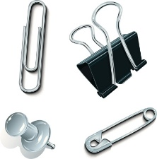

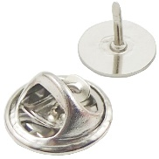

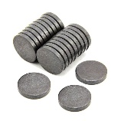

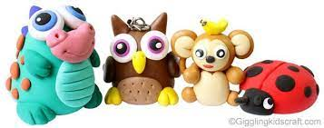

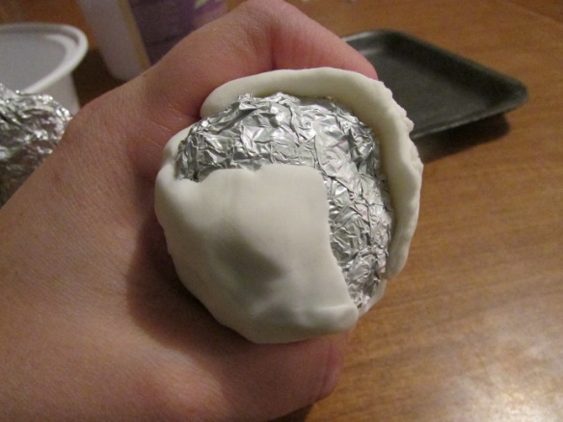

If you are making something large, build the inside with tin foil and then press the self drying clay on top, it will save you some money and time!